CREDIT CARD FRAUD DETECTION

**INTRODUCTION:**

**Purpose of Documentation:**

**Clarification of Objectives: Clearly define the goals and objectives of the credit card fraud detection system, including the specific targets for reducing fraud, enhancing security, and protecting the interests of cardholders and financial institutions.**

**Understanding of Methodologies: Explain the methodologies and techniques employed in the system, such as data preprocessing, machine learning algorithms, anomaly detection, and user communication strategies. Provide a comprehensive understanding of how the system operates and detects fraudulent activities.**

**Risk Mitigation and Security Measures: Outline the various security measures implemented within the system to safeguard sensitive cardholder data and prevent potential breaches. Emphasize the importance of compliance with regulatory standards and best practices in data security.**

**Overview of credit card fraud detection:**

**Real-time Transaction Monitoring: Constantly monitoring transactions for any unusual or suspicious activities.**

**Machine Learning Algorithms: Leveraging advanced algorithms to analyze historical data and identify patterns of fraudulent behavior.**

**Anomaly Detection Techniques: Employing statistical methods and machine learning models to detect abnormal transaction patterns.**

**Behavior Analysis: Monitoring cardholder spending habits and transaction patterns to identify any deviations from the norm.**

**Identity Verification: Implementing robust verification processes, such as two-factor authentication and biometric verification, to ensure the legitimacy of cardholders.**

**Geolocation Data Analysis: Analyzing transaction locations to verify the authenticity of transactions based on the cardholder's typical geographical patterns.**

**Rules-Based Systems: Utilizing predefined rules and thresholds to identify suspicious transactions based on specific criteria.**

**Methodologies and Technologies:**

**Fraud Detection: Identifying and flagging any transactions that exhibit characteristics or patterns commonly associated with fraudulent activities, such as unusual spending behavior, atypical transaction locations, or unexpected transaction frequencies.**

**Risk Management: Assessing and managing potential risks associated with financial transactions, including unauthorized activities, money laundering, or other illicit financial practices.**

**Compliance with Regulations: Ensuring compliance with regulatory requirements and standards set by financial authorities to prevent and detect financial crimes and maintain the integrity of the financial system.**

**Customer Protection: Safeguarding the interests of customers and minimizing the risks of financial losses or identity theft resulting from fraudulent transactions.**

**# Sample code for transaction monitoring**

**# Import necessary libraries**

**import random**

**import time**

**# Simulating a list of transactions (you may replace this with your dataset)**

**transactions = [random.randint(10, 1000) for _ in range(100)]**

**# Function for monitoring transactions**

**def monitor_transactions(transactions):**

**for idx, transaction in enumerate(transactions):**

**print(f"Transaction {idx + 1}: ${transaction}")**

**# Add your monitoring logic here**

**# For example, you can implement checks based on predefined rules or machine learning models**

**# Simulating a delay between transactions for demonstration purposes**

**time.sleep(1)**

**# Call the function to monitor transactions**

**monitor_transactions(transactions)**

**Several machine learning algorithms can be used for credit card fraud detection, depending on the specific characteristics of the data and the desired trade-offs between interpretability and complexity. Here are some commonly used algorithms:**

**Logistic Regression: A simple and interpretable algorithm used for binary classification tasks. It's effective when the data is linearly separable and when feature interpretability is essential.**

**Algorithm Type: Supervised learning algorithm.**

**Classification: Logistic regression is widely used for binary classification tasks, such as distinguishing between fraudulent and non-fraudulent credit card transactions.**

**Key Features:**

**Interpretability: Logistic regression is easy to interpret because it provides a clear relationship between the input features and the likelihood of a particular outcome, making it suitable when explaining the model's predictions is important.**

**Probabilistic Output: It provides a probability score for each prediction, which can be thresholded to classify transactions as fraud or non-fraud based on the level of risk.**

**Linear Separability: It works well when the decision boundary between classes is relatively linear, which may be the case when distinguishing between fraudulent and non-fraudulent transactions based on simple features.**

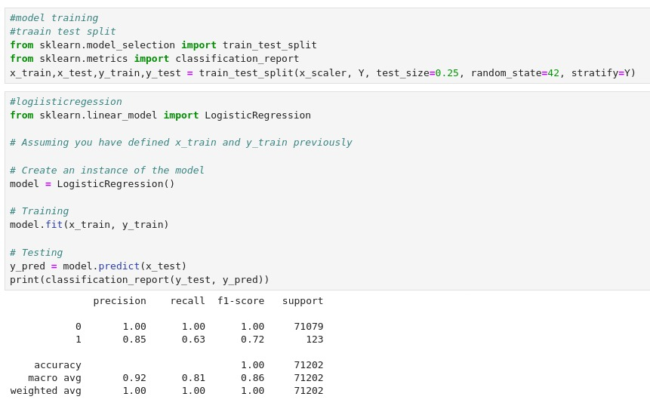

**Isolation Forest Algorithm:**

**Algorithm Type: An unsupervised learning algorithm used for anomaly detection.**

**Key Features:**

**Isolation of Anomalies: Isolation Forest works by isolating anomalies, which are data points that are few and different. It separates the anomalies in the data by randomly selecting a feature and then randomly selecting a split value between the maximum and minimum values of the selected feature.**

**Scalability: It is capable of handling large datasets efficiently and is less sensitive to the size of the data compared to other anomaly detection algorithms.**

**Non-Linear Relationships: Isolation Forest can effectively handle complex, non-linear relationships in the data, making it suitable for detecting fraudulent credit card transactions that may exhibit intricate patterns.**

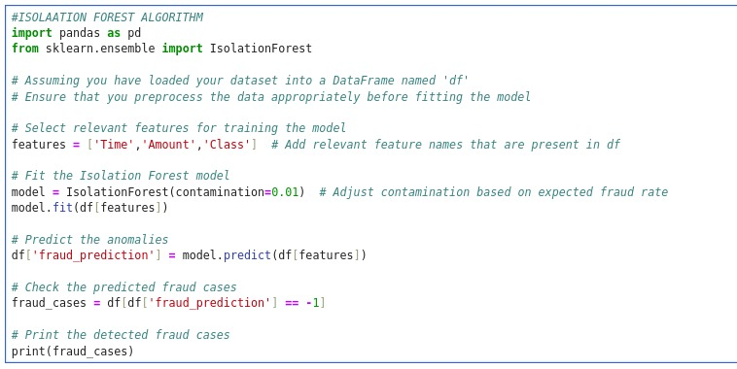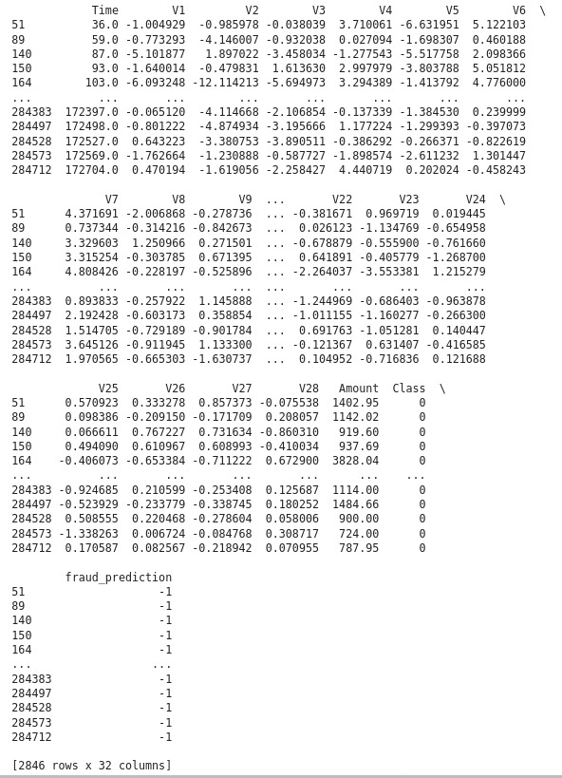

**About Dataset:**

**Features: The dataset includes various features such as transaction amount, transaction time, merchant category, location of transaction, type of transaction (online or in-person), and other relevant details.**

**Labeling: Each transaction is labeled as either fraudulent or legitimate. The dataset contains information about the fraudulent transactions that have been identified and confirmed, enabling the training of supervised machine learning models.**

**Imbalanced Data: Credit card fraud datasets often exhibit a significant class imbalance, where the majority of transactions are legitimate, and only a small fraction of transactions are fraudulent. This characteristic necessitates careful handling during data preprocessing and model training to avoid biased model performance.**

**Anonymized Features: To protect the privacy of the cardholders, sensitive information such as personal details or account numbers may be anonymized or masked, with only relevant transaction attributes included in the dataset.**

**Temporal Aspects: The dataset may also include temporal information, such as the time of day, day of the week, or the date of the transaction, to help capture time-based patterns or trends in fraudulent activities.**

**Data Size: The dataset may vary in size, ranging from a few thousand to millions of transactions, depending on the scale of the problem and the availability of data.**

**Data Quality: Ensuring the quality and reliability of the data is crucial. Data preprocessing steps may include handling missing values, addressing outliers, and standardizing or normalizing features to improve the quality of the dataset.**

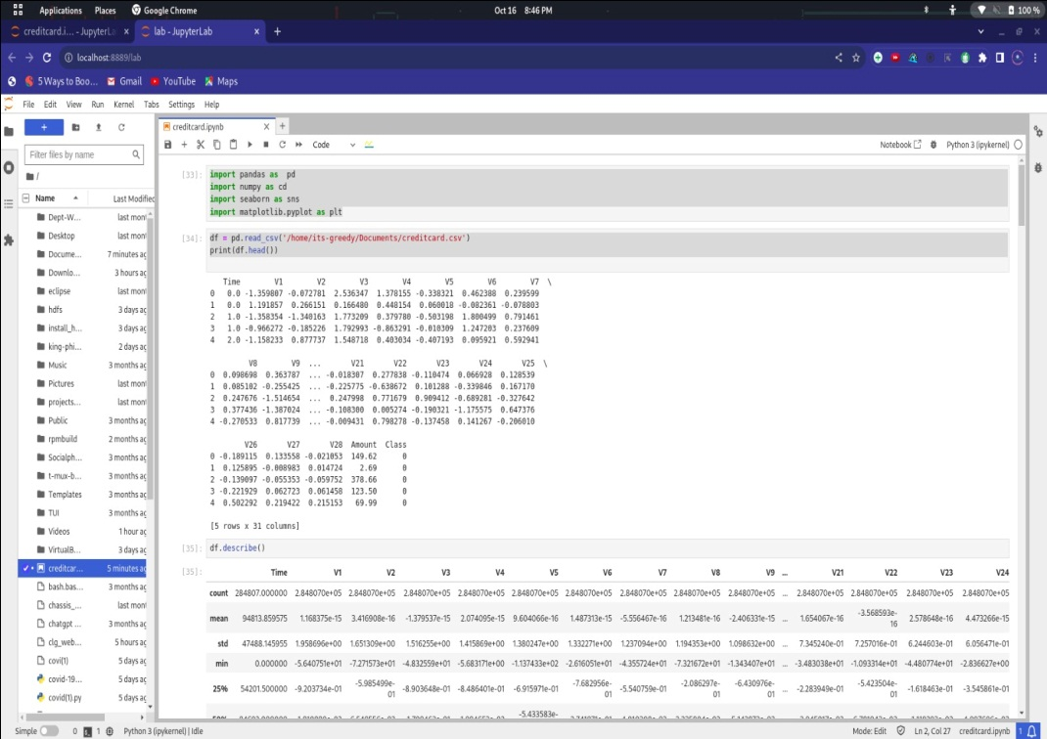

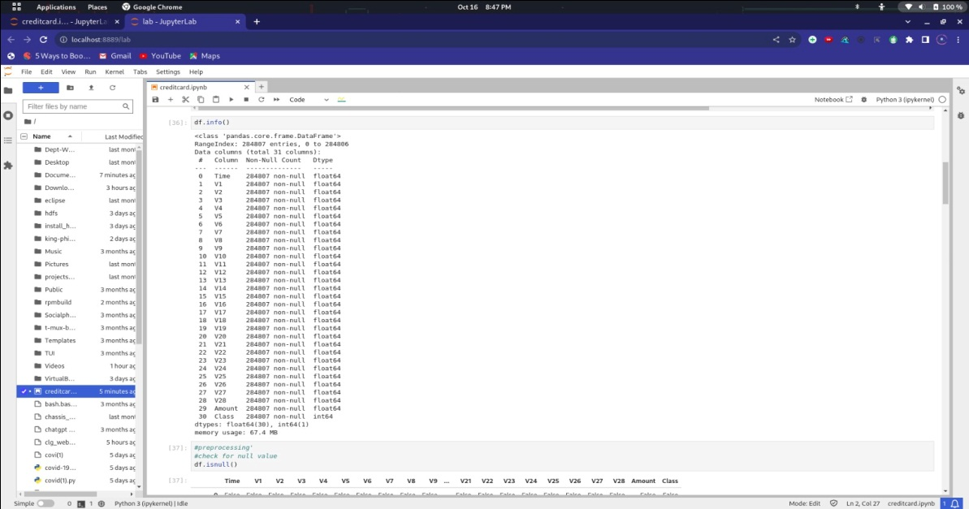

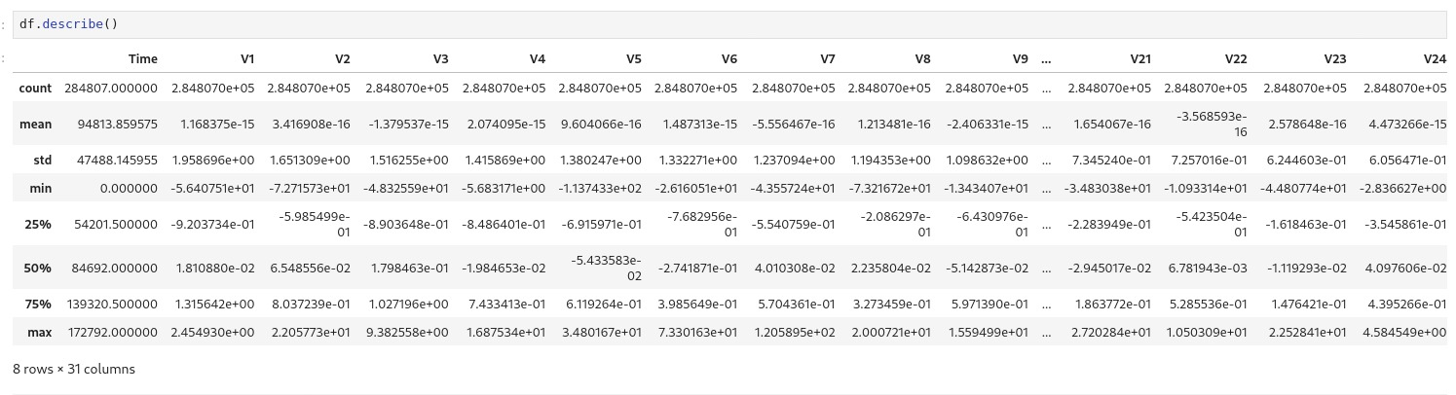

**Data preprocessing:**

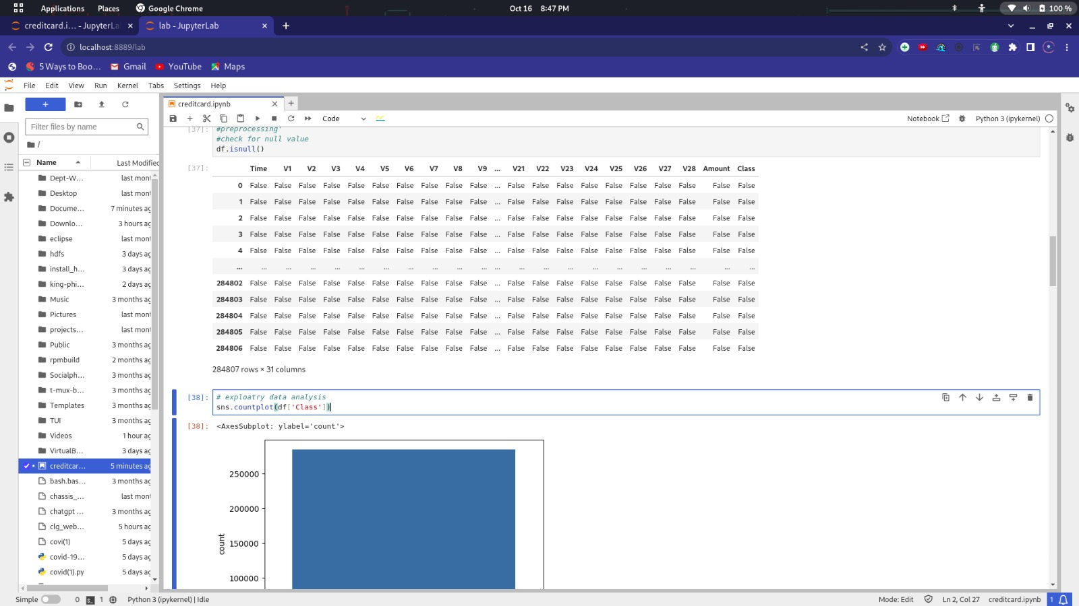

**Data Cleaning:**

**Handling missing values in the dataset by imputation or removal of incomplete data points.**

**Managing outliers that may skew the analysis or model training process.**

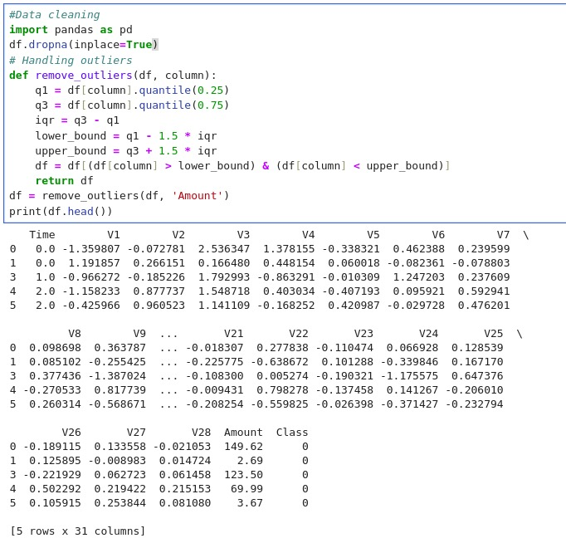

**Data Split:**

**In the context of credit card fraud detection, data splitting is an essential step that involves dividing the dataset into training, validation, and test sets. This process enables the evaluation of the model's performance on unseen data and helps prevent overfitting. Here is an example of how you can split your dataset in Python using the scikit-learn library.**

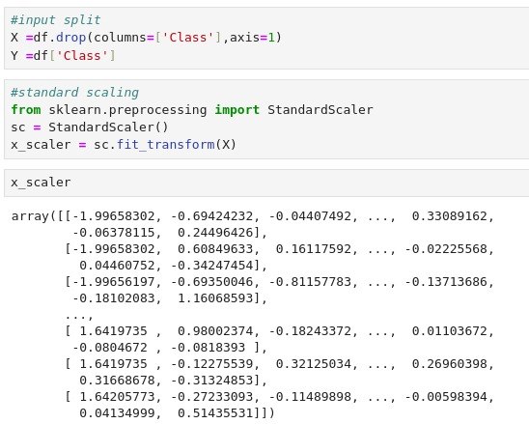

**Co-relation matrix:**

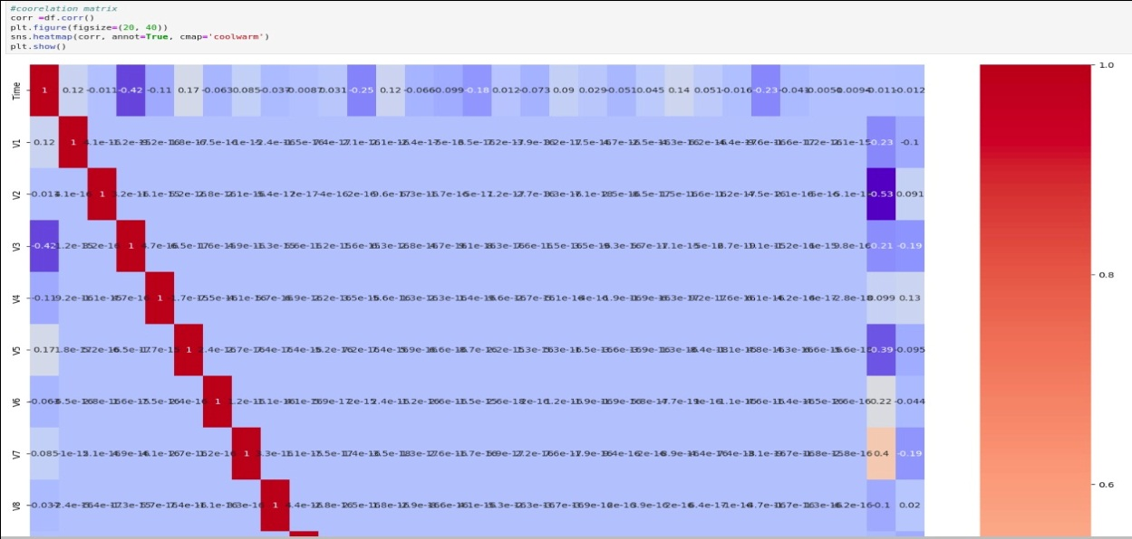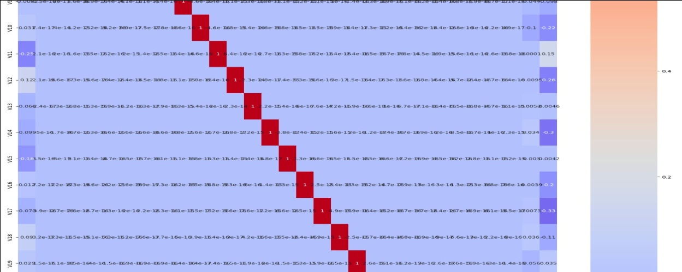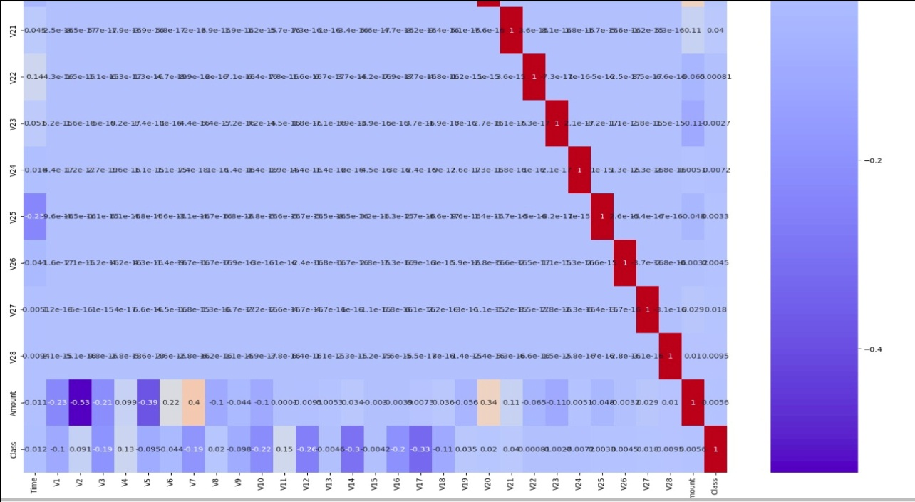

**Exploratory Data Analysis**

**Exploratory Data Analysis (EDA) is a critical initial step in data analysis that involves exploring and summarizing the main characteristics of a dataset. It helps to understand the data, detect patterns, and identify relationships between variables. In the context of credit card fraud detection, EDA is essential for gaining insights into transaction patterns and identifying potential indicators of fraudulent activities**

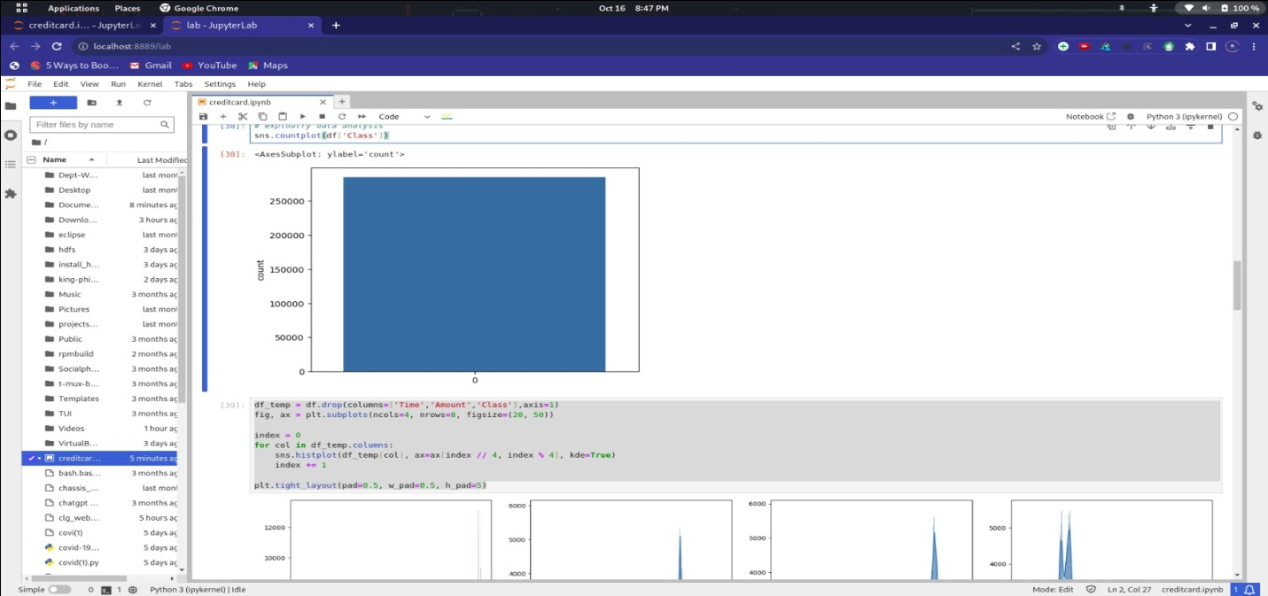

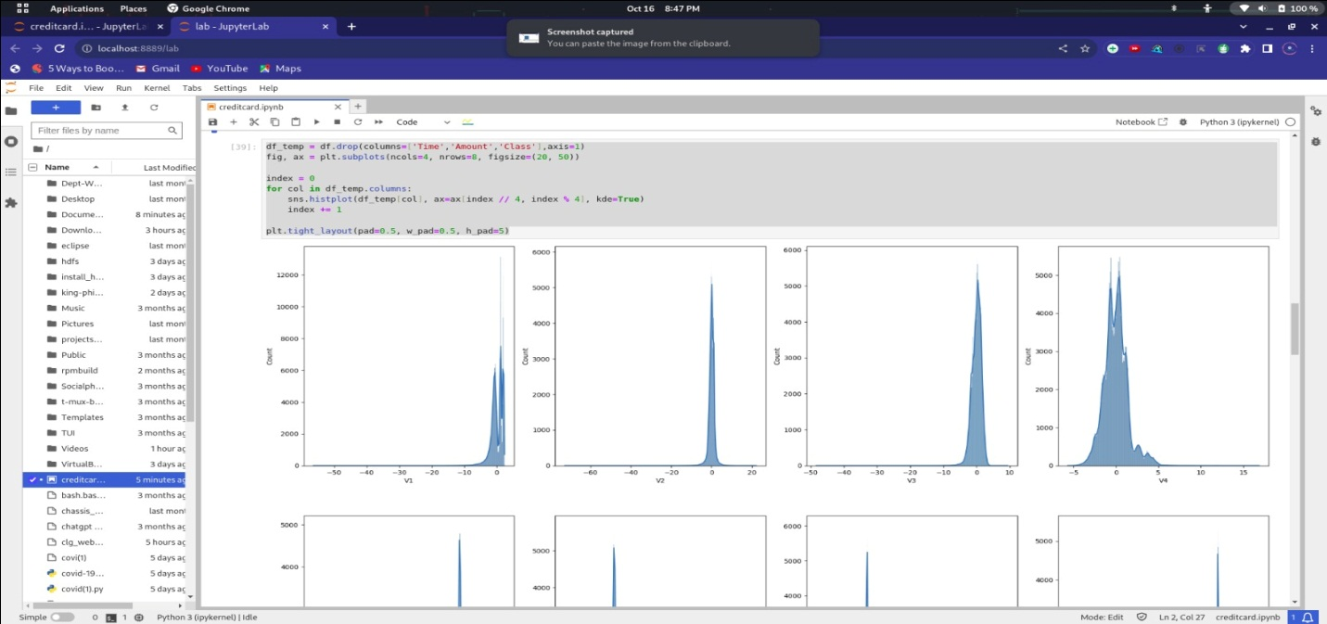

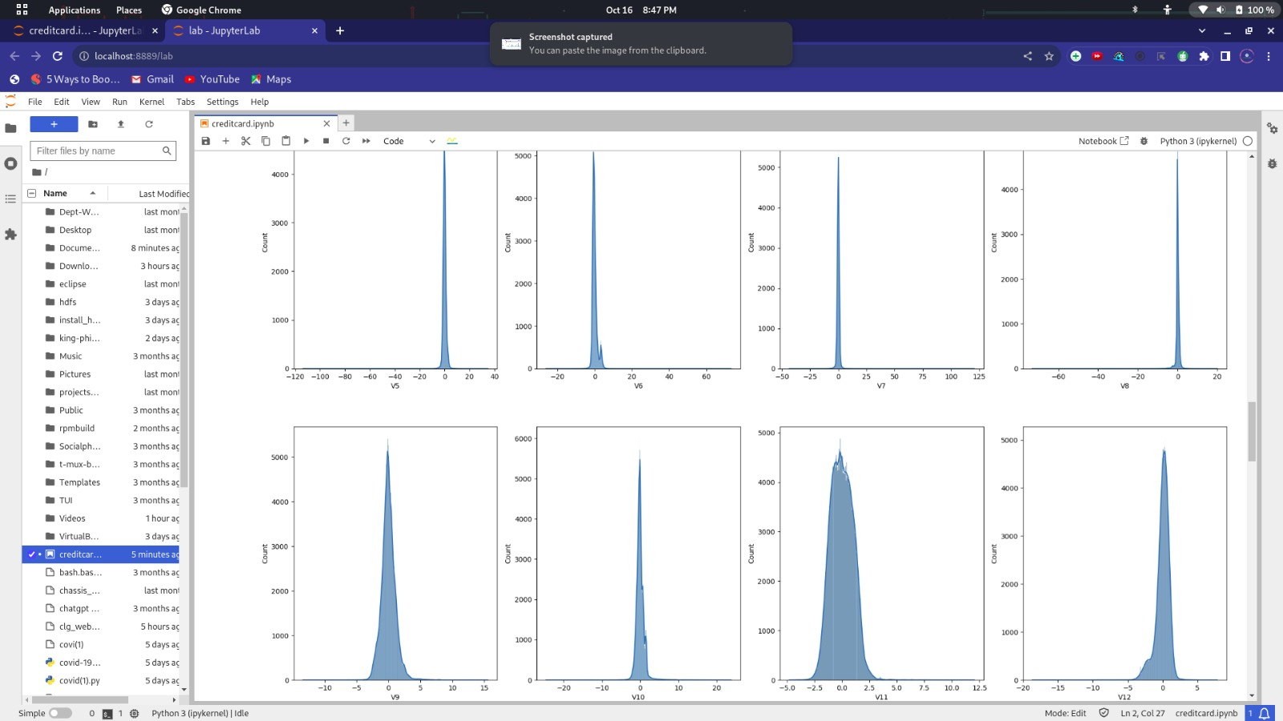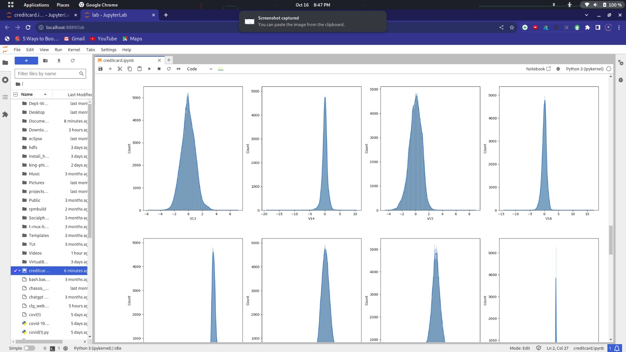

**Model Training:**

**In this script, the dataset is split into training and testing sets using the train_test_split function. A Random Forest Classifier is then initialized with a specified number of trees (n_estimators) and trained on the training data using the fit method. Predictions are made on the test data, and the performance of the classifier is evaluated using metrics such as the confusion matrix and classification report.**

**Make sure to adjust the parameters and hyperparameters of the model to achieve the best performance for your specific dataset. Additionally, consider techniques such as cross-validation and hyperparameter tuning to further optimize the model's performance.**

